Physical modifications in changeover

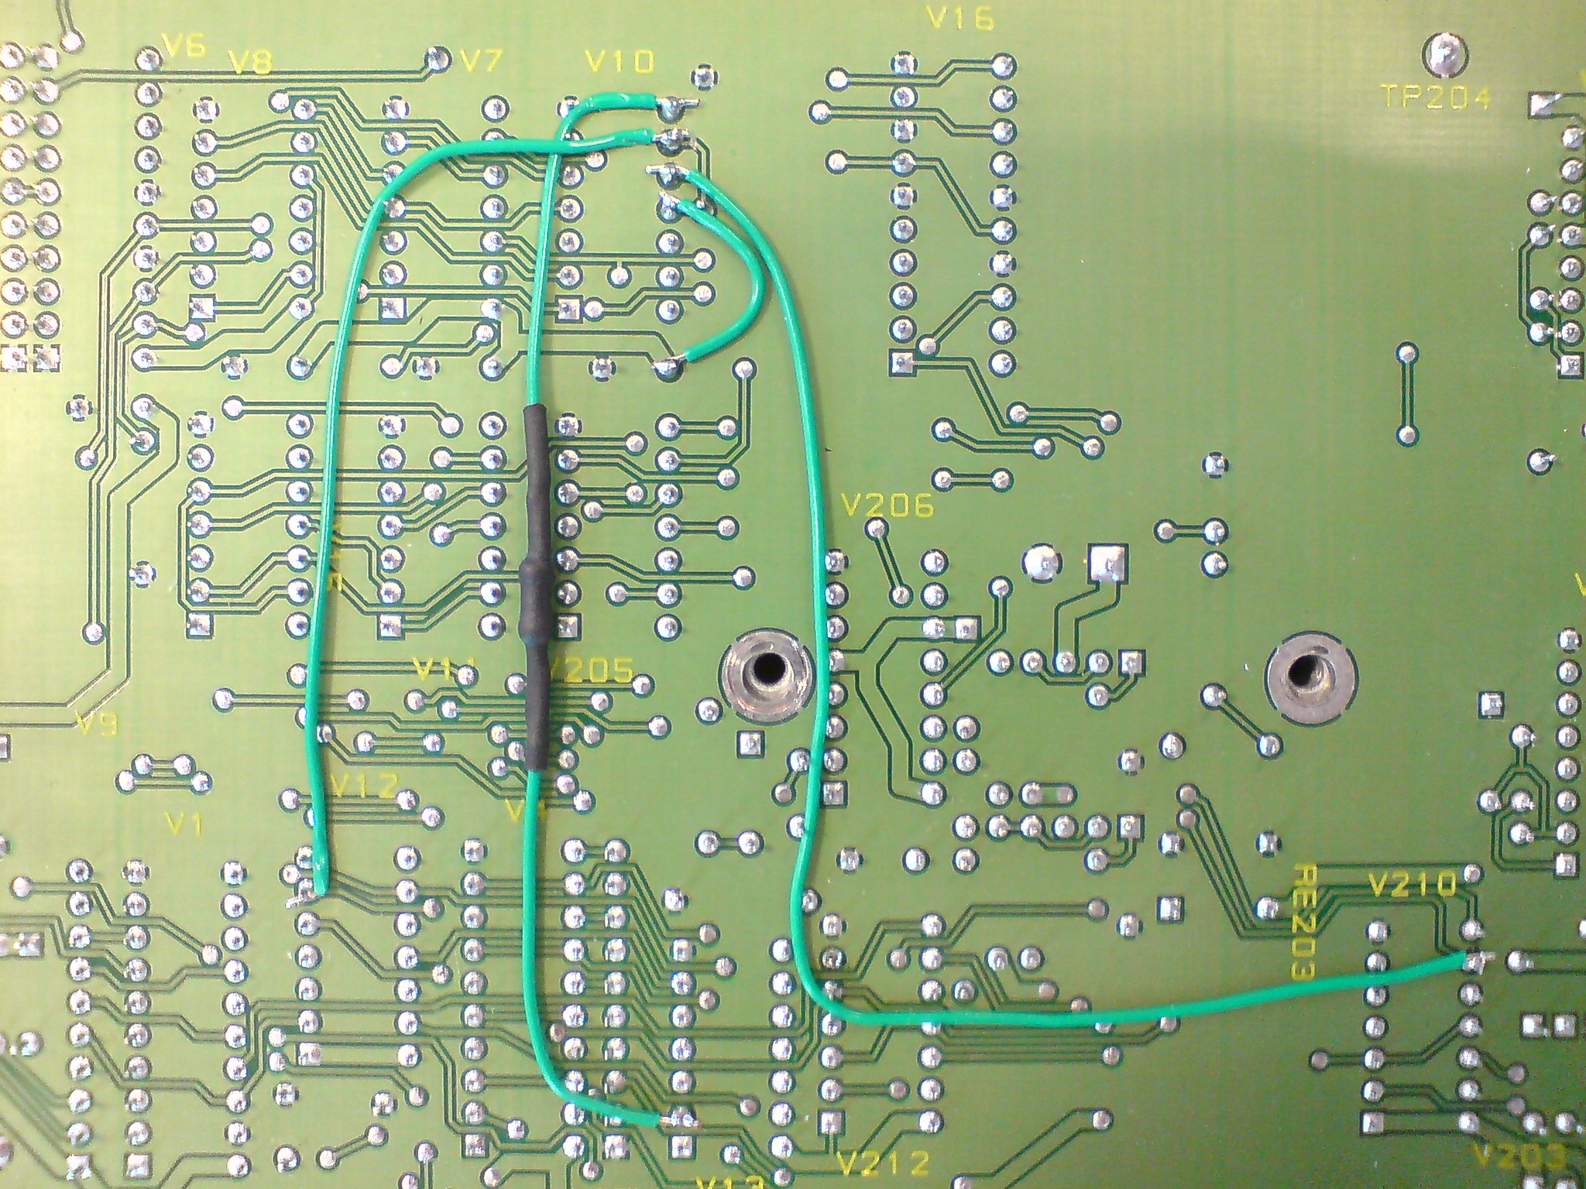
500 ohm
Cut tracks between pin 9, 10 and 11 on V10
Bottom side of mainboard, showing extra wires

Schematic of routing on mainboard

Pin 9 on V210 (manual select) and pin 6 on V12 (remote enabled) is AND'ed in V10. The result is output from pin 3 on V7 and put through a 500 ohm resistor to pin 2 on V13. This pin is also physically connected to the 'manual' button on the changeover front, which is used for resetting an error state.

This means, that if 'manual mode' is selected on the remote and 'remote enable' is on, a reset occours, as if the 'manual' button on the changeover was pressed. Therefore, the error-state is reset, as long as 'manual mode' is set and 'remote enable' is on, and the buzzer will not sound when an error occours. The error LED will still indicate errors. If the remote is disabled while in manual mode, both the buzzer and the LED will indicate errors.

(Caution: Upward facing side of the mainboard is the bottom side. This is important, when indicating pin-numbers, as the IC pinlocations are reversed. Square pads indicates pin 1)

